CodeAIR Mission 1 - Welcome Review Questions

Use this image to answer the questions:
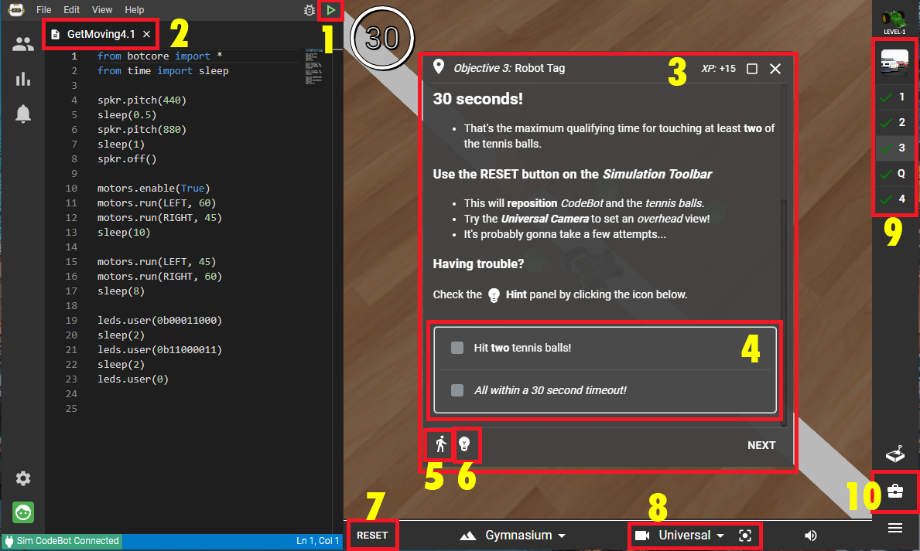
1. Identify #1 | - Debug  - Run  - Filename  - Reset
2. Identify #2 | - Debug  - Run  - Filename  - Text editor
3. Identify #3 | - Objective panel  - Mission panel  - Object goals  - Toolbox
4. Identify #4 | - Objective panel  - Mission panel  - Object goals  - Toolbox
5. Identify #5 | - Objective panel  - CodeTrek  - Hints  - Debug
6. Identify #6 | - Objective panel  - CodeTrek  - Hints  - Debug
7. Identify #7 | - Reset environment  - Camera controls  - Scene volume  - CodeTrek
8. Identify #8 | - Reset environment  - Camera controls  - Scene volume  - CodeTrek
9. Identify #9 | - Objective panel  - Mission panel  - Sandbox  - Toolbox
10. Identify #10 | - Objective panel  - Mission panel  - Sandbox  - Toolbox

